Test Summary Report

1. Project Information
- Project Name: OrangeHRM-Project
- Date: 11-15-2025
1-Kerolous Samuel

2 -Mohamed Radi Goda

3-Zeyad Osama

4-Ahmed Ali
5 –Hazem
- Prepared by: Team 5

2. Detailed Description – Save System User (OrangeHRM)
The Save System User page in OrangeHRM (Admin Module) is used by HR administrators to create, edit, and manage system-level user accounts. This page allows admins to assign login credentials, define user roles, link accounts to employees, and control access to the HR system

2. Key Functionalities
1-Login Function
2-Add Employee
3-Edit Employee
4-Delete Employee
5-leave function

2. Objective
The purpose of this Test Summary Report is to present the overall testing activities for Orange HRM , results, coverage, defects, and quality status of the application under test. It summarizes the work completed, issues identified, and the readiness of the product for release

3. Scope of Testing

In Scope
- Functional Testing
- UI/UX Testing
- Compatibility Testing
- Integration Testing
- Smoke Testing
- Security testing

Out of Scope
- Performance testing
- Non-functional testing not listed in scope

4. Test Approach
The testing process followed the standard QA cycle:
- Expiratory Testing
- Test scenario & test case creation
- Test data preparation
- Execution of manual test cases
- Logging defects with steps, severity, and screenshots
- Re-testing & regression testing after fixes

5. Test Environment
- Environment: QA/ platform
- Browser(s): Chrome, Firefox, Edge
- OS: Windows 10
- Build Version: 64-bit
6. Test Execution Summary
Item | Count
1-Total Test Cases Prepared | 150
2-Test Cases Executed | 105
3-Passed Test Cases | 90
4-Failed Test Cases | 15
5-Test Case Pass Rate | 85%
(Passed / Executed) × 100 | (90 / 105)*100= 85%

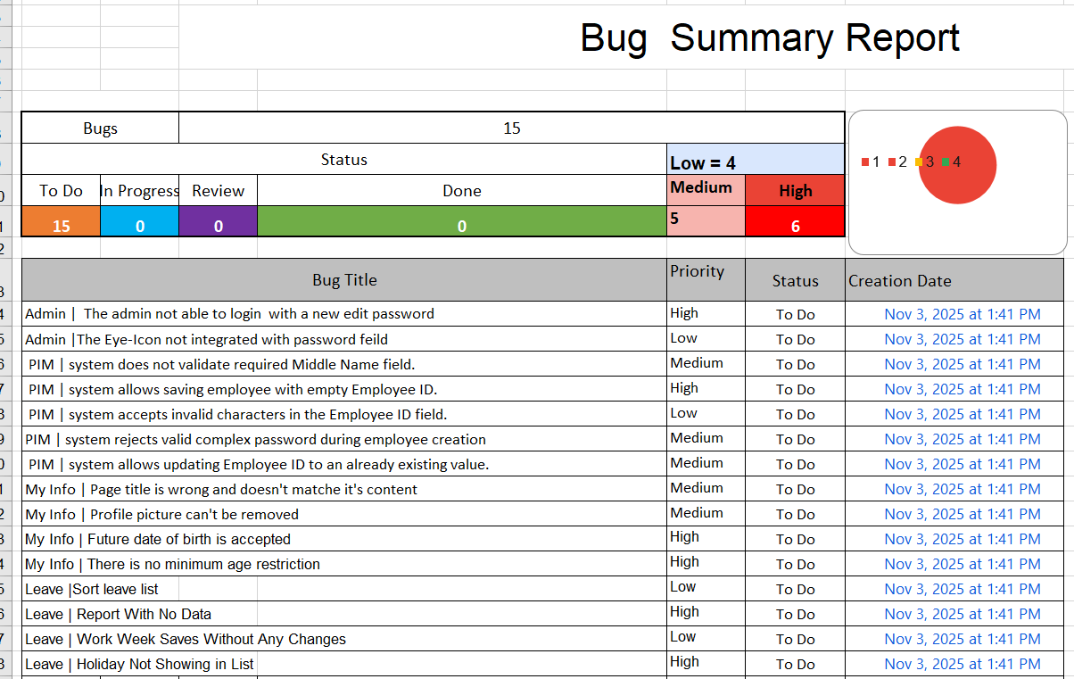
7. Defect Summary
Item | Count
1- Total Defects Logged | 15 Bugs
2- Critical Defects | 6
3- Medium Defects | 5
4- Low Defects | 4

TestCasesLink: https://docs.google.com/spreadsheets/d/12QRmx2VSxtE4yzfqxsOmlj4xuFeDs8BU3JuXnsyYrEY/edit?usp=sharing

